CSA1503-Cloud computing and big data analytics
Experiment-2
Name – Ramya S S
Regno – 192421226
Create a simple cloud software application for Property Buying &amp; Rental process (In Chennai city) using any Cloud Service Provider to demonstrate SaaS include the necessary fields such as Buy, Rent, commercial, Rental Agreement, Rental Agreement, Area, place, Range, property value etc.
INPUT
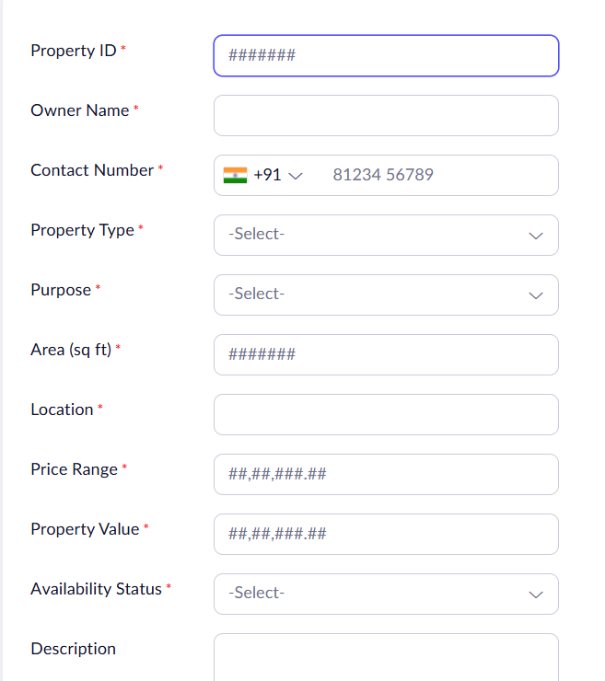

OUTPUT
